**Process Report**

**Scrum-up!**

**Authors:**

**Florin Bordei, 280593**

**Dave Le, 280071**

**Jaume Lopez, 282231**

**Supervisors:**

**Joseph Chukwudi Okika**

**Jakob Knob Rasmussen**

**ICT Engineering**

**3rd Semester**

**20/12/2019**

**34.500 – number of characters**

**Table of content**

Preface iii

1 Introduction 1

2 Group Description 2

3 Project Initiation 3

4 Project Description 4

5 Project Execution 5

6 Personal Reflections 6

7 Supervision 7

8 Conclusions 8

Appendices

# Preface

# Introduction

In the following chapters of this Process Report the reader will go through the stages of the project, it’s progress and also its limitations or incomplete tasks.

Group description section will give a brief introduction and description into the cultural background of each team members and the chosen methods that the team have utilized in analysis of the relations formed inside of the group and how the conflicts have been managed. The team looked also in improving the strength and limiting the negative consequences of weaknesses.

Project initiation part will describe the context on how the group was formed and through which processes the team elected this particular topic and the motivations behind it. In the same time, the tools that the time have utilized will have a brief description.

Project description will contain several topics that are encapsulated into the whole project description. Background description will reveille the investigation performed by the team into the issue found while the Problem Statement and Definition of Purpose are setting up the foundations of the project. In the same section, the reader will be able to read also Methodology, Time Schedule and Risk Assessment.

Project Execution will debate on the methods and project results topics. The group will describe in detail the methods that they have decided to use, how these methods have been followed and what other options would be chosen in case the project will start again. Project results will discuss on the satisfaction of the results, what identified risks have put in danger the satisfaction and how they were solved. It will be an over description of what have succeeded and what was less successful.

Personal reflections will have each team member describing his own private experience from working inside of this group and for this project. It will be described each experience with their own advantages and disadvantages.

Prior to end, Supervision chapter will have the groups reflections on supervision.

Conclusions will end this Process Report with a list of recommendations on what to do and what to avoid doing in a group work.

To be noted that the team have had a total of 30 meetings. In the first 9 meeting the group had done:

* Group formation
* Group contract
* Project ideas
* Project description
* Project description refinement (after feedback from supervisor)
* Product backlog
* Architecture
* Proof of Concept
* Review of team roles

The following 21 meetings have been part of SCRUM, having a total of 7 Sprints with 3 days each.

To be noted that there have been no meetings with the companies as there has been no companies involved in this Semester Project and students had to replicate a problem from a real-life situation and try to find a solution for it.

Inside of these 30 meetings, the team have had 4 meetings with their supervisor.

A full layout of the meetings can be found in the log and Sprint meetings minutes in APPENDIX.

# Group Description

In this section the group will include the cultural background of each member, what team analysis tools of personal characteristics have been used and the personal reflections of each team member on group work.

Florin is from Romania, but for 9 years he has lived in other countries than his own. Most of the time has been spent in Denmark but also countries like Spain, France, Germany, Latvia, Lithuania, Estonia and Slovenia. Prior to this group project, he holds a vast experience in group work in academical and professional environment with stakeholders of different professional and cultural background.

Jaume is from Spain and currently living in Denmark since he started his bachelor education in ICT at VIA University College. Prior to this, he had lived in United Kingdom for a period of three year and also pursued a Mechanical Engineer education at Universitat de Girona, Spain. His group project work experience consists of the two semesters spent at VIA University College, as in his previous educational and professional history he did not had the chance to work in group projects.

Dave is from Czech Republic, originally from Vietnam. He has been studying the whole time in Czech Republic, where education is mainly focused on theory. In rare cases he had the chance to make presentations and to work in group projects, therefore studying in Denmark is a different approach on education for him.

In this Semester Project, the group has not felt that it has been useful Hofstede Model of National Culture. Even if some isolated cases felt like we could have used the Power Distance Index or Individualism versus Collectivism, the group considers that overall the model does not apply in our case.

Tuckman’s tool is to be considered a relevant method of analysis the phases of how the team inter relations and collaboration has evolved over time and how the team went through these phases.

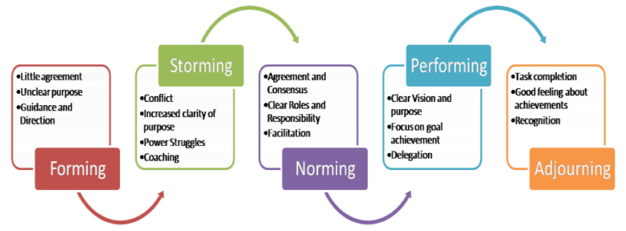

*Source:* [*MSPGUIDE*](http://www.mspguide.org/tool/tuckman-forming-norming-storming-performing)

During the first Sprint, the group has experienced the Forming phase where it has been little agreement but overall the main issue has been the unclear purpose and the lack of guidance. This may have been caused as the group changed the methodology from the 1st Semester and new tools had to be understood and applied.

In our second Sprint the level of conflicts increased as the struggles for power has intensified and communication still has been inefficient or not productive. This has been the Storming phase of the group where it could have been avoided if the group would have asked for more guidance from the supervisors.

Storming phase has continued until the end of the third Sprint and group entered into the norming phase. This has been a result of mutual understanding of each other strengths and weaknesses, a better understanding of the learning objectives of the project and understanding the roles that each team member is playing.

Performing has been facilitated also by the change of the working space as the group moved from working in temporary spaces to a permanent space and the group could enjoy also lunches and coffee breaks together. This brought the group more united and it facilitated to have a clearer vision and focus on the goals.

As stated on [e-stimate](https://www.e-stimate.com/tools/personality-profiles/about-personality-profiles/) : “Using the tools creates an understanding of employees’ and managers’ personal drivers, strengths and approach to others. Important knowledge in an organization that must develop and perform well every day”. This statement is strongly supported by the team as it beliefs that the personality profiles that each of the members has it should have been discussed prior to project initiation. E-Interpersonal profiles characteristics played an important role over the first three Sprints until each member understood each other’s characteristics.

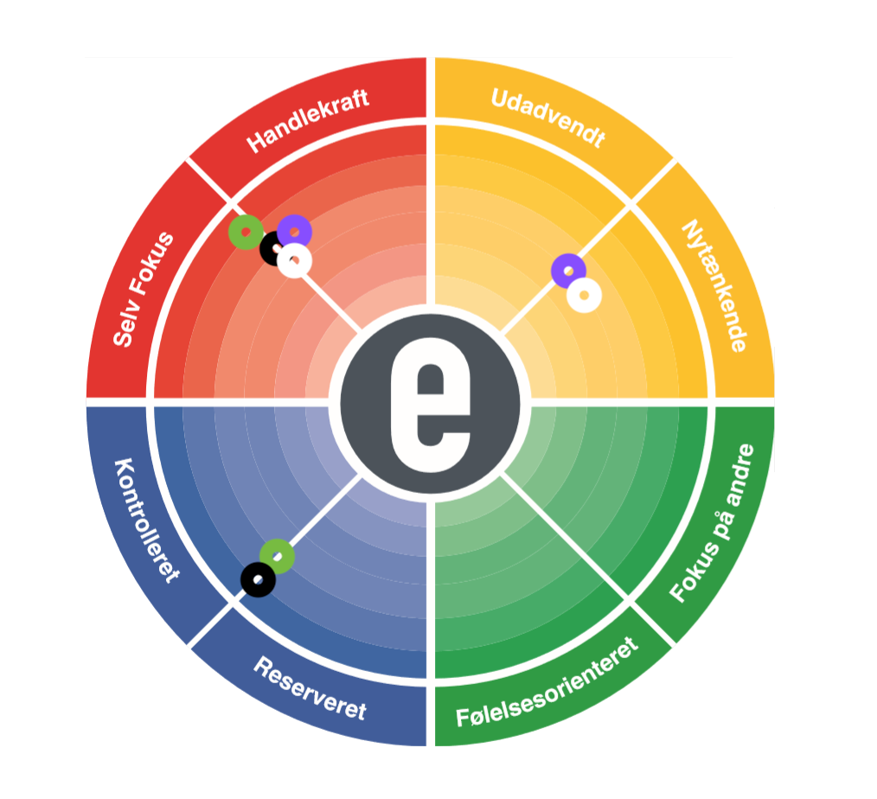

***Source:*** [***e-stimate***](https://www.e-stimate.com/)

***Florin – Black***

***Dave - White***

***Jaume – Purple***

By looking at the model of characteristics, we can realize that the group had a lot of members in the red area where there have been struggles of power that caused most of the conflicts. The red area being characterized by Dynamic and Whip, or Executor, this created conflicts on the role of team leadership for which direction the project should follow and what methods and concepts should be implemented. Another reason for creating the conflicts has been also the direct manner of communication which was not very well accepted by other group members as they felt that they are not listened or taken in consideration for their contributions. This situation shifted around by having the group members in red changing their direction for creating results and being resourceful which facilitated collaboration.

Group members from the yellow area had contributed with their creativity and positive atmosphere but also being innovative and enthusiastic. Same members have given inspiration to the group to be more focus oriented but also to try new ideas for the functionalities that have to be implemented.

Group members from the blue area brought a more professional and controlled communication and helped with understanding better the guidelines that the group has to follow to complete the project. They also contributed with their attention to details and documentation.

The group would have been balanced if there would have been a member in the green area that has the team role of solving conflicts and pulling the team together.

Overall, the differences and the advantages of each area created a balance between the team members and conflicts have been reduced to minimum, group collaboration had increased, and the working atmosphere has turned into a positive one.

# Project Initiation

During the first days of September 2019, the team has met to discuss the new project semester inside of the SEP3 classes but also outside of them. There have been many debates on different project ideas and, similar to last year, we’ve had three options to choose from. The team put it to a vote and one idea had a majority vote. Secondary, the idea has been tested out with one of our supervisors and that represented the whole starting point of the project. The team has decided to try to develop a Scrum tool that would facilitate their work on future projects that will use the Scrum framework. Also, a second reason to choose this particular topic would be the opportunity to fully strengthen the team’s knowledge within Scrum framework but also the role experiences as the team has decided to rotate the roles for this semester.

Group formation has been initiated by the whole team as it been decided to work inside of the same team of previous semester. The team members have expressed in the last semester the needed motivation to perform such a project and also the dedication. Despite the efforts to keep the group intact and performed to the agreed standards and objectives, the team has suffered alterations in late November 2019 when one of our team members, Kenneth Jensen, expressed for unknown reasons an unusual behavior and lack of communication from his side. Prior to this, each team member has tried to improve the situation and consolidate the relationships with him, but it looked like there is no other options than continuing on different paths. To be noted, that the team had almost 8 attempts to mitigate this situation before it was too late. This situation brought a setback in the project development, but the rest of the team had no other option than controlling as much as possible the damage and continue with the project in this new format. His role as Product Owner has been given to Florin Bordei, while Dave Joe (Scrum Master) and Jaume Lopez (Developers) kept their roles.

Team meetings took place accordingly with the posted SEP3 schedule on itsLearning but there have been supplementary meetings also. We had less alterations than last year but, as it is out of control, there have been few members missing meetings due to sickness or mandatory work duties in their part time jobs. These absences have been announced in due time and there have been no internal issues.

Team’s motivation has been damaged a bit during the last weeks of October and the month of November when the problems raised with our ex team member Kenneth as there has been a large number of missed meetings from his side without any announcement or excuses and it created some tension inside of the team on how to proceed with this situation.

As for planning tools, the group has used:

* Google Calendar – dates and times of meetings
* Facebook Messenger group chat – for written messages
* Discord – for group calls/ remote meetings
* Github – work files sharing platform
* Google docs – sprint’s todo’s lists
* Scrum – framework for developing and delivering

As stated in the [Scrum’s Guide](https://www.scrumguides.org/scrum-guide.html), “Scrum is a framework within which people can address complex adaptive problems, while productively and creatively delivering products of the highest possible value”.

Briefly, Scrum has three pillars: transparency, inspection and adaptation. Transparency refers that the process must be visible for the all the members involved for the end result of the project, inspection on the Sprint Goal and progress to identify undesirable variances and adaptation having the process or the material adjusted if the resulting product will be unacceptable.

Group 3 has applied Scrum framework for their Semester Project by creating a Product Backlog with the user stories that have been formulated. There have been a number of seven Sprints, each Sprint of 3 days. The members involved have played different roles, with different responsibilities: Development Team, Scrum Master and Product Owner.

At the end of each Sprint, the team have held a Retrospective meeting, Review meeting and Planning meeting. In each of these meetings the team, Product Owner and Scrum Master have discussed the progress, the risks, the improvements and other relevant issues critical for the product development. During these meetings the Sprint’s Backlogs, Product Backlog and Burndown Charts have been updated. In Sprint Planning the next Sprint was planned by selecting the next user stories to be worked on according to priority and user story points. The following days of the Sprints had a short Daily Sprint Meeting where it was discussed the progress from the previous day, the plan of the current day and if any issues are detected and how they can be resolved.

Attached to Appendix, the reader is able to see the development of each Sprint: selected user stories and their progress, minutes of the meetings, Burndown Chart and Product Backlog.

# Project Description

# 4.1 Background Description

The Danish educational system encourages the use of the PBL approach to learning, as it helps students to make a deeper integration of theoretical and practical learnings. At the same time, it supports collaborative learning and helps the students to become more motivated and independent learners with a deeper subject understanding.

VIA University College is also using this learning approach inside of the course named “Semester Project” that is taught every semester. Each semester involves unique methods and requirements to be fulfilled by the students. Therefore, the students must identify a problem on which they are going to work collaboratively to find a solution using certain methods and frameworks.

As a result, the software engineer students are required to develop a software solution system for a given or identified problem. In this process, it is required to use certain development methodologies and frameworks.

Starting with the first semester, students apply the Waterfall model, that comes with certain limitations. Most significant limitations include high amount of risk, long waiting time for running software, inability of changes.

Starting with the second semester, students are introduced to new methodologies and frameworks, that they can apply in their new Semester Project. As an alternative to Waterfall Model, the students are required to use Unified Process, that is popular iterative development process for building object-oriented systems. As mentioned earlier, UP overcomes the limitations of the Waterfall Model by being able to deliver running parts of the system through its iterations. Each iteration includes its own requirements analysis, design, implementation, and testing activities.

Alongside the UP, students are also required to use SCRUM framework, which addresses complex adaptive problems, while productively and creatively delivering products of the highest possible value. The framework consists of Scrum Teams and their associated roles, events, artifacts and rules. Each component within the framework servers a specific purpose and is essential to Scrum’s success and usage. The rules of Scrum bind together the roles, events, and artifacts, governing the relationships and interaction between them.

The Scrum Team consists of a Product Owner, the Development Team, and a Scrum Master. The Product Owner is responsible for maximizing the value of the product resulting from work of the Development Team. The Development Team consists of professionals who do the work of delivering a potentially releasable increment of “Done” product at the end of each Sprint. The Scrum Master facilitates the implementation of Scrum framework and is a servant-leader for the Scrum Team. Scrum Teams are self-organizing and cross-functional. The teams deliver products iteratively and incrementally, maximizing opportunities for feedback, incremental deliveries of “Done” product ensure a potentially useful version of working product is always available.

The heart of Scrum is a Sprint, a time-box of one month or less during which a “Done”, useable, and potentially releasable product Increment is created. Sprints have consistent durations throughout a development effort. A new Sprint starts immediately after the conclusion of the previous Sprint. Sprints contain and consist of the Sprint Planning, Daily Scrums, the development work, the Sprint Review, and the Sprint Retrospective.

Artifacts defined by Scrum are specifically designed to maximize transparency of key information so that everybody has the same understanding of the artifact. The Product Backlog is an ordered list of everything that is known to be needed in the product. It is the single source of requirements for any changes to be made to the product. The Sprint Backlog is the set of Product Backlog items selected for the Sprint, plus a plan for delivering the product Increment and realizing the Sprint Goal. The Scrum Burndown Chart is a visual measurement tool that shows the completed work per day against the projected rate of completion for the current project release. Its purpose is to enable that the project is on the track to deliver the expected solution within the desired schedule.

Even though the Scrum and UP are simple to understand, it is difficult to master and fully implement them as it has been observed from previous second semester students.

Regarding Scrum, initiating and managing the artifacts causes misunderstandings among the students as there are not many templates available. Additionally, there are issues in storing artifacts in a logical manner. For example, in the Sprint Backlog the students omit the assigning the responsibility of a user story to one of the member’s group and breaking down the user story into multiple tasks with their specific story points. Consequently, if the user story was not broken down into tasks, the Product Backlogs’ user story points will not be successfully updated, this situation includes also Burndown chart. Another issue the students are facing while using the Scrum framework is that they are not properly following the order of events and a lack of a clear overview regarding the issues that have been reported in each meeting. Because of a badly stored and managed data, it is difficult to extract required documentations for the Project and Process Reports. In some cases, it has been noticed a lack of communication from the student’s side towards their supervisors and this has created situations, where the supervisors were not aware of the lack of progress.

Regarding UP, the biggest challenge faced by the students is a rush to code instead of following strictly UP model. That is a consequence of misunderstanding UP model, but also a lack of task management. To help the reader to understand better, in each iteration (Sprint) the selected user stories are being considered as “Done” once the following have been completed: Analysis, Design, Implementation, Testing, Deployment.

# 4.2 Problem Statement

The software engineer students of the second semester are facing challenges as they are new adaptors of Scrum and UP frameworks. The consequence is that students are not fully productive in their first Sprints.

# 4.2.1 Main question

What kind of integrated system students need, and which parts of the SCRUM process this system can manage?

# 4.2.1 Sub-questions

What data needs to be stored, and how?

What kind of data analyses the system needs to perform?

What kind of data report should the system generate?

Who can manipulate specific data?

# 4.3 Definition of purpose

The purpose is to create a system that will help provide students with guidance through the SCRUM process from inception to delivery with the aim of learning outcome of Scrum and UP frameworks for the students.

# 4.3 Delimitations

Due to limited team members in the group, as the group context changed, security will not be implemented but it will be included in analysis and design.

Aim of the group has been to achieve a system that will enable the users the students to navigate through the Semester Project while using SCRUM framework. The goal has been to create a platform that would enable the users to create accounts, be able to register groups, be able to edit the groups and be able to input and output their work.

The team has been able to deliver core functionalities so we can conclude that there are satisfaction factors at the end of the project.

To be noted that the group does not consider that the system is complete and further3 improvements can be implemented for this particular system. Future developments can be discussed inside of Project Report. To be noted that security has not been implemented due to team size change.

# Project Execution

The current Product Backlog holds 54 user stories from which the group delivered 25 user stories during the seven Sprints. To be noted that initially as the team consisted of 4 team members, it has been estimated that the group will have an amount of 1120 hours invested in the project but that number reduced as the fourth member decided to leave the group.

During Sprint#1 and Sprint#2 same user stories have been worked on as the user from Sprint#1 have not been completed and it has been the team’s decision to continue working with them also in Sprint#2.

As a user I need to be able to create an account so I can be added to a group.

As a user I need to be able to log in to the system so I can access the system

As a user I need to be able to create a group so that our sprints can be organized

As a manager I need to be able to add and remove members from a group to keep the correct members in the group

As a manager I need to be able to remove group members from a group to keep the correct members in the group

As a manager I need to be able to create a product backlog to store the user stories of the system

As a manager I need to be able to add user stories to the product backlog to keep track of the current user stories

But unfortunately, we were unable to finish them also by the end of the second Sprint as we had issues in how to make the connections between the tiers. We’ve tried different options but we were unable to make the connection completely work. So, again they have been moved in the third Sprint.

During Sprint#3, the following user stories have been selected:

As a manager I need to be able to set the number of sprints so that we can have an overview of the total number of sprints

As a manager I need to be able to set the duration of each sprints so that they accurately depict the time spent

As a manager I need to be able to edit the number of Sprints in case the initial number was a mistake.

As a user I need to be able to create an account so I can be added to a group.

As a user I need to be able to log in to the system so I can access the system

As a user I need to be able to create a group so that our sprints can be organized

As a manager I need to be able to add and remove members from a group to keep the correct members in the group

As a manager I need to be able to remove group members from a group to keep the correct members in the group

As a manager I need to be able to create a product backlog to store the user stories of the system

As a manager I need to be able to add user stories to the product backlog to keep track of the current user stories

During this Sprint there have been no issues and the user stories have been completed without any issues.

During Sprint#4, the following user stories have been selected:

As a manager I need to be able to add user stories to a sprint to keep the accounts accurate

As a manager I need to be able remove user stories to a sprint to keep the accounts accurate

As a manager I need to be able to add tasks to user stories to break down tasks and make them more approachable

In this Sprint we had some issues and conflicts with the database, and we needed to make sure that we return specific views for specific groups.

In Sprint#5, the following user stories have been selected:

As a manager I need to be able to change the access of the members so that everyone has the correct authorization

As a manager I need to be able to assign story points to a user story to accurately depict the progress

As a manager I need to be able to create a sprint daily meeting note to keep accurate documentation of the project

As a manager I need to be able to create a retrospective meeting note to keep accurate documentation of the project

As a manager I need to be able to create a Review meeting to keep accurate documentation of the project

As a manager I need to be able to create a planning meeting note to keep accurate documentation of the project

In this Sprint here have been no issues and user stories have been delivered successfully.

In Sprint#6, the following user stories have been selected:

As a manager I need to be able to view the backlog items from Product Backlog so I can be aware of the current status of the project

As a manager I need to be able to see the current Sprint Backlog so I can have an overview of the current progress.

As a manager I need to able to view my group members and their assigned roles so I can have a complete overview of my group

Process Report

Project Report

Security assessment

And in Sprint#7, it has been selected:

Process Report

Project Report

Security assessment

As a manager I need to be able to view the meeting notes so I can have an overview on the situation

As a manager I need to be able to see the status of the current tasks so I can be aware of the progress of my team.

As a manager I need to be able to edit the meetings so I can avoid human errors.

In the last two Sprints there have minor issues, but they have been fixed without any issues and the focus in the last Sprint has been more on documentation.

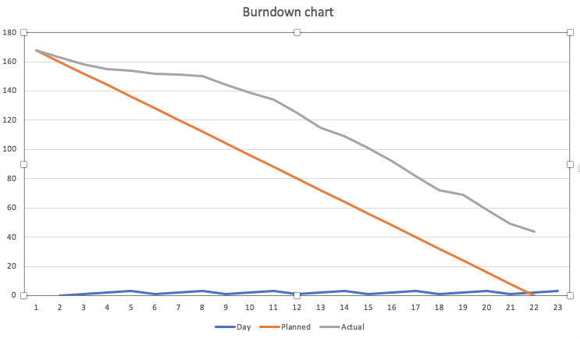

# Personal Reflections

* Personal reflections Florin Bordei

The group contract content covered the following topics: participation, communication, meetings, conflicts and other issues. Each section of the group contract contained guidelines on what is expected individually from each member but also what is the group general expectations. In this sense I must admit that the group covered all topics related, unless communication where there have been some issues and misunderstandings. What has missed, and it would have made a difference, is the methods to apply in case one of the group members does not follows the guidelines. Overall, I am satisfied with the group contract and how it has been followed. It must be also taking in consideration that it’s a new group and the issues that we have met are ordinary.

Issues met like communication have been resolved and the expected results have been delivered.

As all members involved, I had been involved in most of the areas of the project but with a small deficiency in the implementation that followed analysis and design phases. We delegated the tasks according to each individual strength and weaknesses starting with Sprint #3 so we can be more efficient in our work methodology and this has proven to be successful as results started to be delivered. In my case, I would say that I was a key person to remember the group about the learning outcomes and the importance of documentation but overall, I can’t really point myself with a unique contribution as the group contributed equally in terms of work and quality of the results. I much more satisfied in such a situation, if I have to compare with the project from the 2nd Semester.

Group’s motivation has been at risk multiple times when we have faced endless conflicts on small issues and also lack of communication has brought the group’s welfare in danger. But, as I said previously, I have expected such situations thinking of the experience from 2nd Semester. Despite what happened in the past, the group moved into the norming and performing phases much faster than last year and the stress or conflicts reduced immediately, and the quality of relationships improved greatly. Also, by knowing each other a bit better, we realized that we share common interests or beliefs, and this strengthened our bond. If there would be possibility to work in the same group for next projects, I would not think twice about it and join it.

Multicultural group is a very relative term for me as living abroad for so many years I have borrowed so many traits and habits from different nationalities that I have interacted with and it’s really difficult for me to make a difference in this case. Therefore, I learned new habits on how I could work in the next group projects refined from my own perspective.

For the next time I when I will work in a group, I would insist to have a meeting where to discuss into details the e-stimate personal profile traits as they applied successfully in this group, despite having some conflicts created by those differences. This must be understood from the very beginning, like who would have a strong leadership role that may cause conflicts and try to find a balance before the group work starts.

The advantages of problem-based learning are that you utilize multiple sets of knowledge that are applied in a single body. The positive outcome of it that the learning process of this knowledge is deeper and also you visualize it more applicable in reality.

The disadvantage in our situation has been the lack of clarity. As in 1st Semester we have been presented with a clear case that needs to be solved, this year we have to imagine a case, and this created some issues in relation to vision: where does it starts and where does it end. We have tried to replicate as much as possible to reality, but I feel that in some cases we’ve focused on issues that are not that relevant in a real situation.

Problem formulation and project description are critical for the quality of the end results of the project as they give vision and they build the path that needs to be followed and the disadvantages would be the opposite results of what I have previously mentioned.

Collaboration with the supervisor was as expected, we had meetings where Steffen had guided us or advise us on what needs to be improved. There is nothing that I can mention as being less successfully. We have talked with our supervisor for different issues: project description, problem formulation, Sprint structure, issues with implementation and documentation. Communication has been made verbally and in written over e-mails.

* Personal reflections Jaume Lopez

I consider that I have underestimated the importance and the critical role of formulating a group contract that would cover all the layers of working in a group project. I think that if we’ve had formulated conduct guidelines it would have help with eliminating some conflicts that have not brought any contribution.

Also, a penalty system for being late or missing out of meetings without any reason would have made the attendance more mandatory and team members would have felt more responsible.

In this project I’ve tried to be involved and responsible in all parts related to the system. But I focused most of the time on the database related parts, as I thought It would be a great opportunity to learn and improve my knowledge in this field. On a group role, I can consider myself as the person who reminded the group of the deadlines that we have and that we need to deliver results at the end of each Sprint.

Inside of team work I have met difficulties in cooperating with some of the group members as there’s been a clash of ideas that pursued and continued over some of the first Sprints and this affected our productivity. For the next group projects, I will try to accommodate more needs or my team members and try to find a balance between our perspectives and approaches.

Sprint #3 has been the moment when the group started to be fully functional and results started to be delivered.

I consider group work and problem-based learning a great opportunity where you can practice all the knowledge that you have studied during the current Semester and also there is a precious amount of shared knowledge from other team members that is highly valuable. Therefore, I consider that there are no disadvantages in this way of working.

The only thing that needs to be taken in consideration and to be looked into it is the amount of stress that is generated and how it can damage personal or group welfare. But also, we have to keep in mind that under pressure and stress great results can be achieved.

* Personal reflections David

Looking back at the group contract, most of the rules which are set there were followed without much problems. In a few meetings, one of the group members could not attend due to health problems, therefore group’s motivation and progress was not going as smoothly as planned. As a group, we attempted several times to work online, but as it was not very efficient, we moved to eye-to-eye communication, which got proved to be the right decision and work progress got much more forward. In the future projects, conflict management should be handled in better ways – by prioritizing the areas of conflict and avoiding arguing, which would not lead anywhere. Many times, there were arguments, as members’ attitudes allowed them to be honest and to say without any problem, what they do not like or what would make them more comfortable.

On the other hand, I feel, like at the end those conflicts set off discussions on improvements, taught us to listen others and helped us to know each another’s limits. At the end, we got over it to the performing stage. Overall experience about the group following the contract was good and covered my expectations.

Main ideas about implementing the features for the system came from other members, as they had already got experiences from working in the industry. From the beginning of the scrum we tried to equally share tasks and finish the user stories, but not everything went smoothly, we rushed to the code implementation without proper analyzing the structure of the system. We decided to use another philosophy of working, that means knowing each’s strengths and weaknesses, which we found out was a better way of cooperation.

All members were interested in delivering the best quality product. That also brought the conflicts, as each of us wanted to present his own idea/point of view along with misunderstandings. As close friends, all of us tried to keep atmosphere nice, we motivated us by planning non-project meetings to strengthen our friendship bonds.

The multicultural group was one of the things I was interested mostly, as I had no large experience with the group, let alone with multicultural one. The very good point of this is the possibility to have a look on different approaches to work and cooperate together. Even though all of us are from EU, I like a big tolerance and respect for cultural differences. Another advantage is a diversity of knowledge, we can have a larger pool from which we can take an inspiration and skills, therefore we can deliver much more multifarious product, which you cannot in normal conditions make in your home country. All of us do not just grow educationally, but also culturally by knowing each other’s culture.

I believe, that the biggest challenge was in some cases less faith and increased competition, which at the same time was good, as it driven higher productivity.

From problem-based learning methodology, I realized, that it can be very effective, as you are more involved in it, if the is enough motivation to solve the problem. You need to also learn, how to even solve something and there are no clear rules to do it. The learning process for me seems to visualize a theory into the reality, and it is also very good in the future, as you can meet similar issues. By making descriptions, all of us can understand much more clearly all the structure of the project and put all ideas from our brains to the documentation like jigsaw puzzle. Among the disadvantages, I feel like sometimes it can be time consuming to make part of documentation, which I know, will not be useful in the future.

Supervisor meetings were going as I expected, and they covered all the questions, we had and ensured uncertain things we met in the project. It is very important for not going out of the path.

# Supervision

The group considers that the supervision had been helpful, and it led to greater understanding of the project and its scope.

Inside of team discussions and reflections it has been mentioned that mandatory meetings with the supervisor would have been appreciated as the team often found itself in time consuming difficulties that could have been resolved within a meeting, but the team never considered the possibility of assistance.

# Conclusions

The experiences gained in this Semester Project have taught the team what it means to work within SCRUM framework and its benefits. Increments have been added periodically and the team has experienced a similar working experience to a real-life work situation.

Also the opportunity to work and develop a ntier architecture system gave us a new perspective on our studies and the potential development that we can reach. It had allowed us to manifest new traits but also brought worthy experiences.

New personality traits have been understood better, as in e-stimate, as in this Semester Project there have different role plays of different roles with different attitudes and responsibilities. We could include also here the importance of the group contract that should never be ignored and try to improve and impose the contract rules more in the next group works.

“Rush to code” concept have been understood and it had an impact on the productivity of the team, but it’s been a learning outcome also as it made the team to fully understand and appreciate the phases prior to implementation and delivery.

Each Semester Project it is an opportunity of gaining new knowledge and skills, so the team recommends that for each Semester Project to fully embrace the experience and the learning outcomes that comes with it.

**Appendices**

Appendix E – Product and Sprint Backlog, Minutes of the meetings, Project Description, Group Contract, Log

**Sources:**

MSP Guide. 2012. Tuckman model. [ONLINE] Available at: <http://www.mspguide.org/tool/tuckman-forming-norming-storming-performing>. [Accessed 2 June 2019].

E-Stimate. 2015. E-Stimate model. [ONLINE] Available at: <https://www.e-stimate.com/wp-content/uploads/sites/16/Doris-Muster-.pdf>. [Accessed 3 June 2019].

Scrum Guide. 2018. Scrum Guide. [ONLINE] Available at: <https://www.scrumguides.org/scrum-guide.html>. [Accessed 4 June 2019].

Conolly, T. and Begg, C., 2010. *Database Systems*. 5th ed. US: Pearson Education.

Larman, C., 2004. *Applying UML And Patterns*. 3rd ed. US: Pearson Education.

jrebel.com. 2014. Object-oriented design principles and the 5 ways of creating SOLID applications. [ONLINE] Available at: <https://jrebel.com/rebellabs/object-oriented-design-principles-and-the-5-ways-of-creating-solid-applications/>. [Accessed 15 May 2019].

docs.oracle. 2017. Lesson: All About Sockets. [ONLINE] Available at: <https://docs.oracle.com/javase/tutorial/networking/sockets/index.html>. [Accessed 15 May 2019].

https://www.ibm.com. 2006. Traceability from Use Cases to Test Cases. [ONLINE] Available at: <https://www.ibm.com/developerworks/rational/library/04/r-3217/index.html>. [Accessed 20 May 2019].

docs.oracle. 2019. Guarded Blocks. [ONLINE] Available at: <https://docs.oracle.com/javase/tutorial/essential/concurrency/guardmeth.html>. [Accessed 13 May 2019].

sourcemaking.com. 2019. Observer Design Pattern. [ONLINE] Available at: <https://sourcemaking.com/design_patterns/observer%E2%80%8B%E2%80%8B>. [Accessed 13 May 2019].

via.itslearning.com. 2019. The Observer Design Pattern (SVA, February 2019).pdf. [ONLINE] Available at: <https://via.itslearning.com/LearningToolElement/ViewLearningToolElement.aspx?LearningToolElementId=364658>. [Accessed 13 May 2019].

en.wikipedia.org. 2019. State pattern. [ONLINE] Available at: <https://en.wikipedia.org/wiki/State_pattern>. [Accessed 13 May 2019].

sourcemaking.com. 2019. Visitor Design Pattern. [ONLINE] Available at: <https://sourcemaking.com/design_patterns/visitor>. [Accessed 13 May 2019].

geeksforgeeks.org. 2019. Java Singleton Design Pattern Practices with Examples. [ONLINE] Available at: <https://www.geeksforgeeks.org/java-singleton-design-pattern-practices-examples/>. [Accessed 13 May 2019].